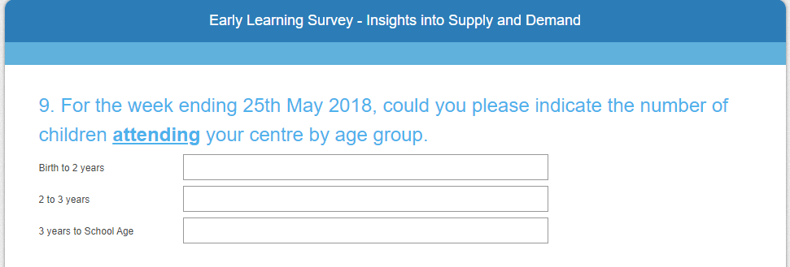

Log into Xplor
Click on Master Roll on the left hand side of the page
Hover over the Date directly above the list of children and go back to the required date

Go through and count each child based on age to fit into the allocated category

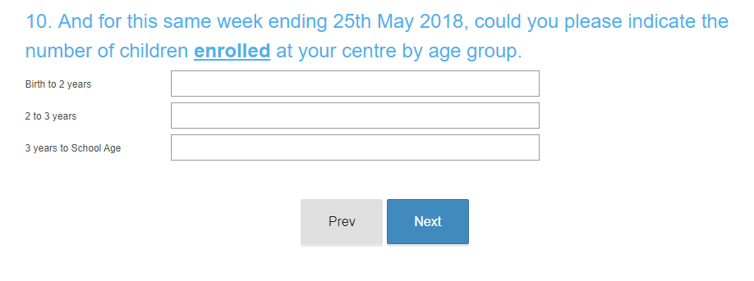
Follow prompts above and ensure that you are on the ALL ROOMS as this will show all children enrolled

The next following questions will ask you for the same information, utilize the above notes and screenshots to assist you.

