Qikkids Rolls > Summary> Dates>Roll Summary type> Utilisation
1)
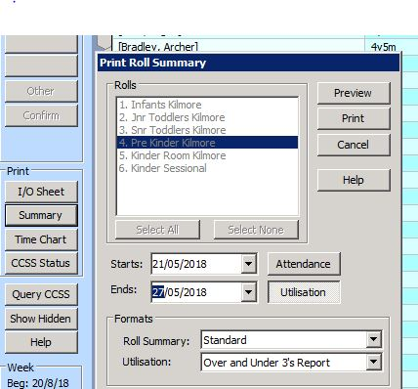
2)
